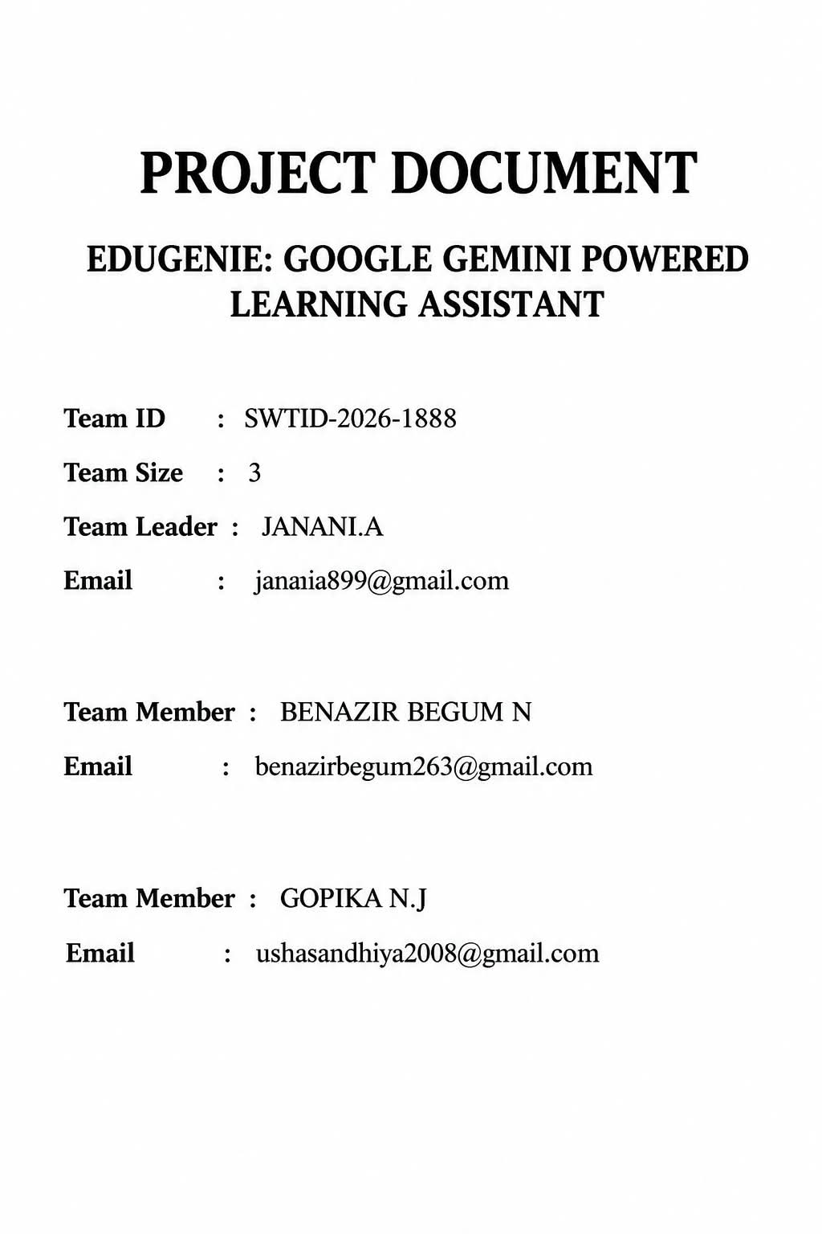

EduGenie: Google Gemini Powered Learning Assistant

Project Description
EduGenie is a lightweight educational assistant powered by generative AI. It is designed for learners across academic levels and supports common study tasks such as:
- Ask questions and receive smart, concise answers
- Understand complex concepts through simplified explanations
- Generate quizzes from topics or text
- Receive personalized learning recommendations
- Summarize large educational passages
EduGenie uses FastAPI for backend services and a simple HTML+CSS interface for interaction. It combines lightweight local models with cloud-based AI services, providing useful learning features while remaining practical for resource-conscious environments such as Mac M1 systems.
Scenarios
Scenario 1: A student wants to know about oceans and rivers uses EduGenie to ask “Which is the largest ocean?”
Scenario 2: A student wants to know the level of her understanding of “The Pythagoras Theorem” and clicks “Generate Quiz.”
Scenario 3: A learner studying SQL requests a structured learning path that progresses from beginner concepts to advanced topics and includes suggested timelines and resources.

ARCHITECTURAL DIAGRAM
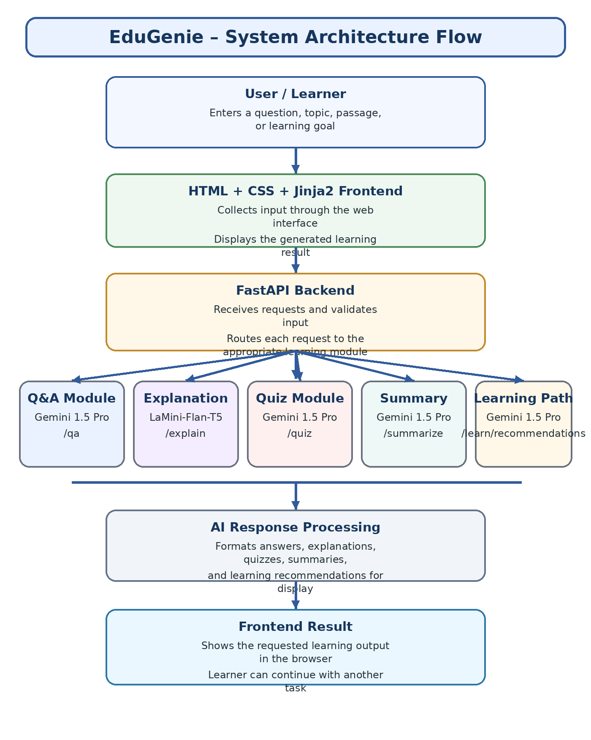

Pre-requisites

Python 3.10+
- Official Documentation: Google AI for Developers
- Installation Guide: Tom's Hardware
- Popular Tutorial: Python Programming Tutorial - Full Course for Beginners
- Installation Steps:
- Download the latest Python 3.10+ installer for your operating system from the official website.
- Run the installer and ensure you check the box that says "Add Python to PATH".
- Follow the installation prompts to complete the setup.
- Verify the installation by opening a terminal or command prompt and typing python --version.

- FastAPI Framework –
- Official Documentation: FastAPI
- User Guide: FastAPI
- Popular Tutorial: FastAPI Crash Course
- HTML & CSS – Basic templating used in /templates and /static

Google Gemini API Key
- Official Documentation: Google AI for Developers
- Setup Guide: GeeksforGeeks
- Popular Tutorial: How to Use Google Gemini API Key
- Setup Steps:
  - Visit the Google AI Studio and sign in with your Google account.
  - Create a new project and enable the Gemini API.
  - Generate an API key and securely store it.

Uvicorn (ASGI Server)
- Official Documentation: PyPI
- Installation Steps:
  - Install Uvicorn using pip: pip install uvicorn

Jinja2 (HTML Templating Engine)
- Official Documentation: Jinja2 Documentation
- Installation Steps:
  - Install Jinja2 using pip: pip install jinja2

Project Workflow
MILESTONE 1: Model Selection and Architecture
Activity 1.1: Select AI Models
- Gemini 1.5 Pro (via API):
Used for: Q&A, summarization, quiz generation, learning paths
Benefits: Advanced reasoning, structured outputs, and cloud inference
- LaMini-Flan-T5-783M (local):
Used for: Concept explanation
Benefits: Instruction-tuned, lightweight, CPU-compatible
Folder Architecture:
EduGenie/
- main.py # FastAPI app
- explanation_module.py # Concept explanation logic
- qna.py # Question answering
- quiz_module.py # Quiz generation
- summary_module.py # Summarization
- learning_path.py # Learning recommendations
- templates/index.html # HTML frontend
- static/style.css # Styling
- requirements.txt # Python dependencies

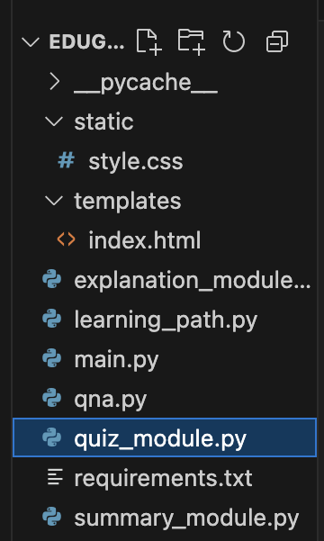
FIG. Showing the Folder Architecture
MILESTONE 2: Core Functionalities Development
Activity 2.1. : Module Implementation
- Explanation Module
EduGenie uses LaMini-Flan-T5 as a lightweight local model for explaining educational concepts. Its instruction-tuned design helps convert complex material into concise, readable explanations that are easier for beginners and self-learners to follow. By emphasizing clarity and manageable responses, the module supports foundational learning without requiring extensive technical background.
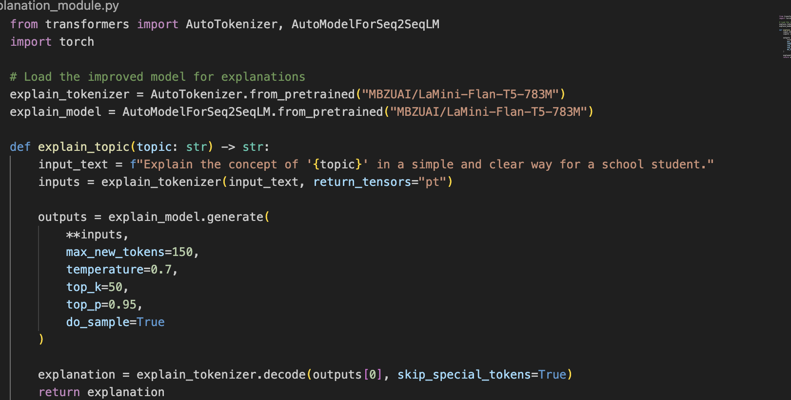
Fig. Explanation module logic
- QnA Module
EduGenie uses Gemini 1.5 Pro for question answering across general and academic topics. The model processes the user's question in context and produces a focused response, making the QnA module suitable for learners who need quick AI-assisted support across different subjects.
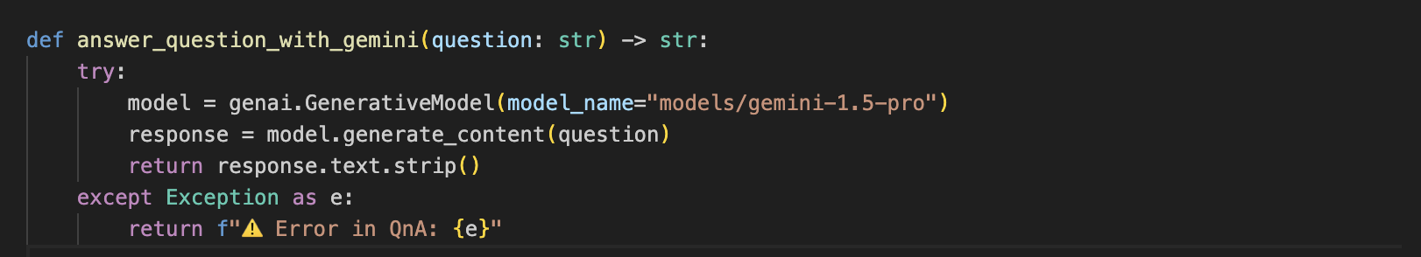
Fig. Q/A Module
- Quiz Module
The Quiz Module creates three multiple-choice questions from the supplied passage, with four options for each question. Gemini analyzes the passage so that the questions remain relevant to its meaning and the incorrect options act as plausible distractors. The result is returned in a structured JSON format for straightforward integration.
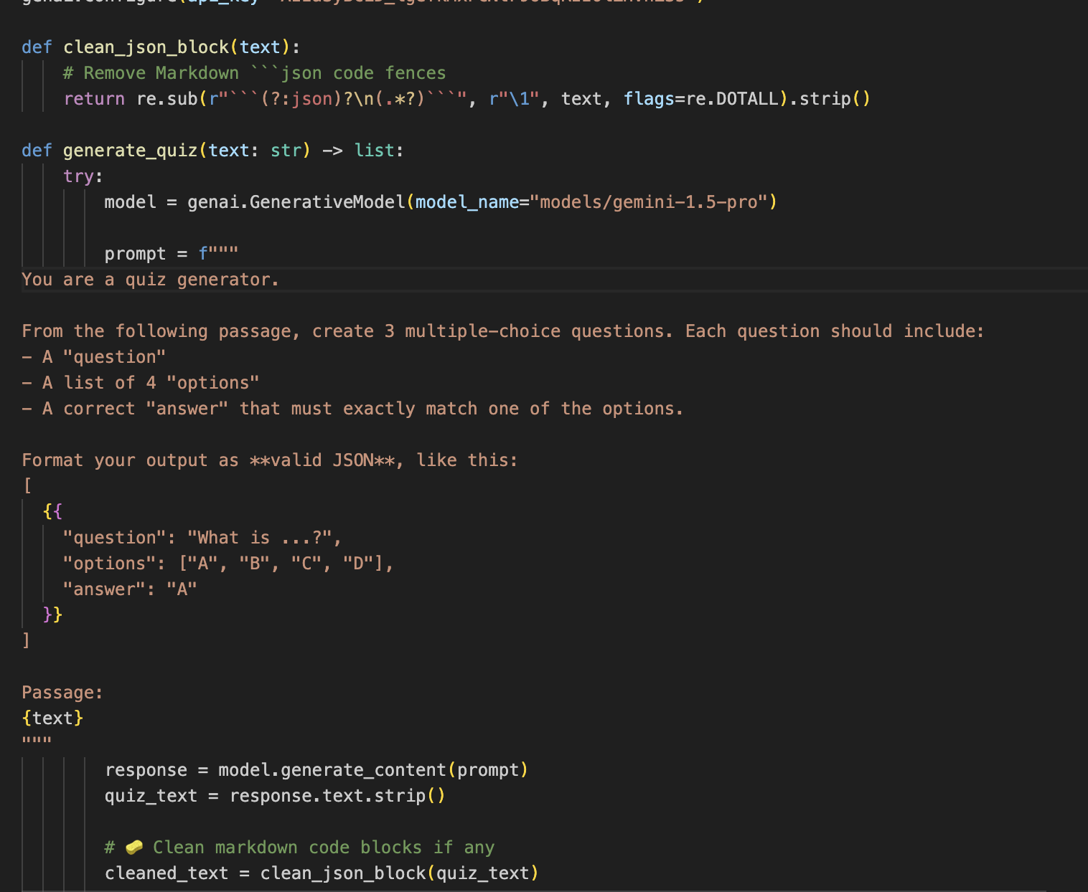
Fig. Quiz Module Logic
The module sends a structured prompt and expects valid JSON containing the questions, four options, and the correct answer. Any Markdown code fences are removed with the clean_json_block function before the response is parsed into a Python list. If generation or parsing fails, the module returns an error message that can be used for debugging.
- Summary Module
This feature uses Gemini to condense lengthy educational passages into clear summaries for faster revision. It preserves the important information while reducing repetition, helping learners review key ideas without losing the original context.
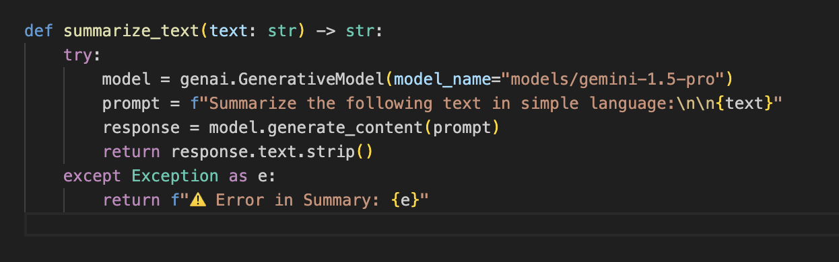
Fig. Summary Module

- Learning Path Module
The get_learning_recommendations function uses Google Gemini to build a structured learning path for a selected topic. The prompt asks for concepts from beginner through advanced levels, arranged by difficulty and supported with resources such as videos, articles, or books. The function also handles invalid responses and API errors so that the learner receives either the generated plan or a useful error message.
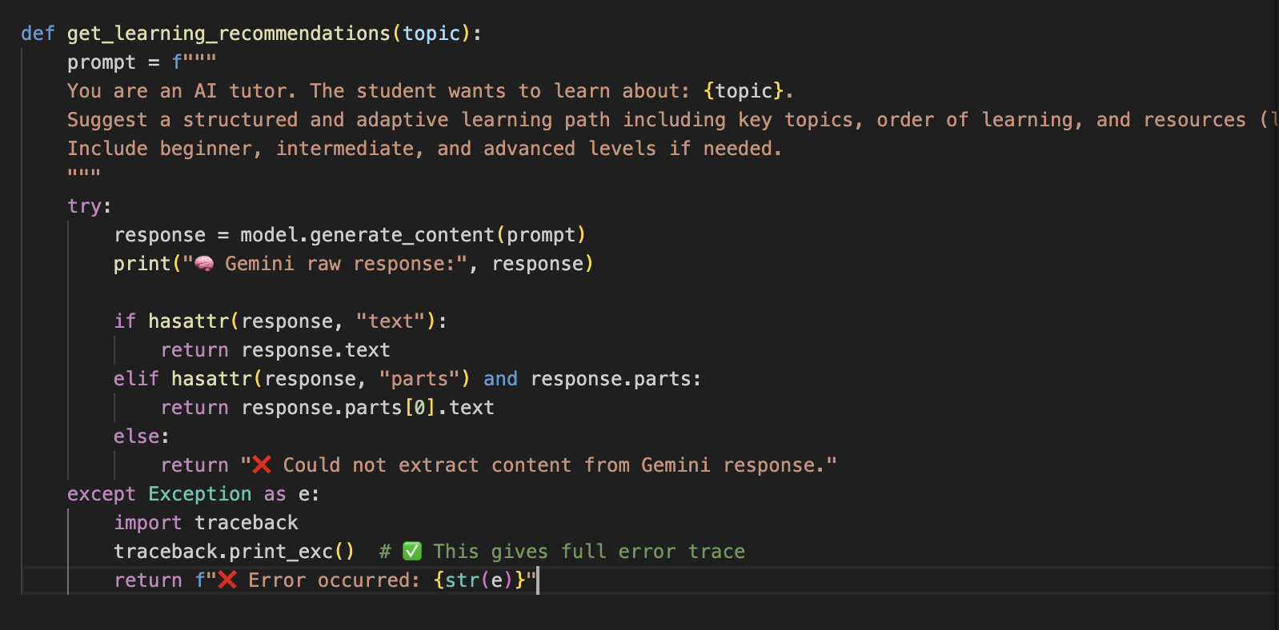
Fig. Learning Path Module

Activity 2.2 : Backend API with FastAPI
- Defined RESTful endpoints for each module:
  - /qa
  - /explain
  - /quiz
  - /summarize
  - /learn/recommendations
- Connected each endpoint to a respective module logic
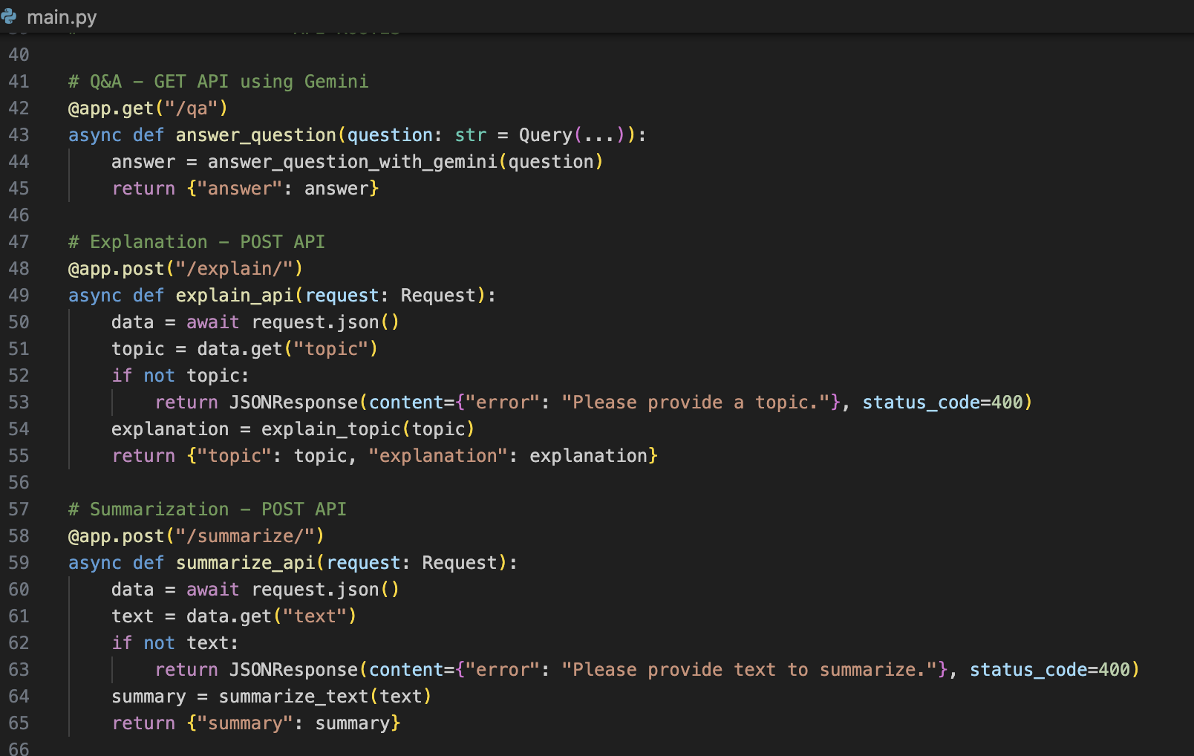
Fig. Endpoints of API
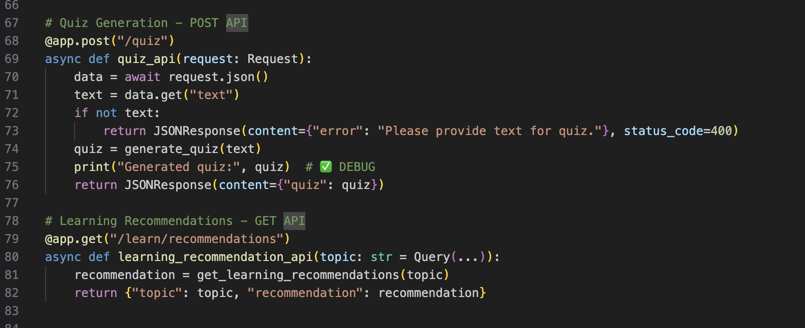
Fig. Endpoints of API
MILESTONE 3: Frontend Development
Activity 3.1: Build Web Interface
- HTML Form (index.html):
  - Task dropdown (Explain, QnA, Quiz, Summary, Recommend Path)
  - Text area for user input
  - Submit button
- CSS Styling (style.css):
  - Responsive design
  - Styled buttons, input areas, and result container
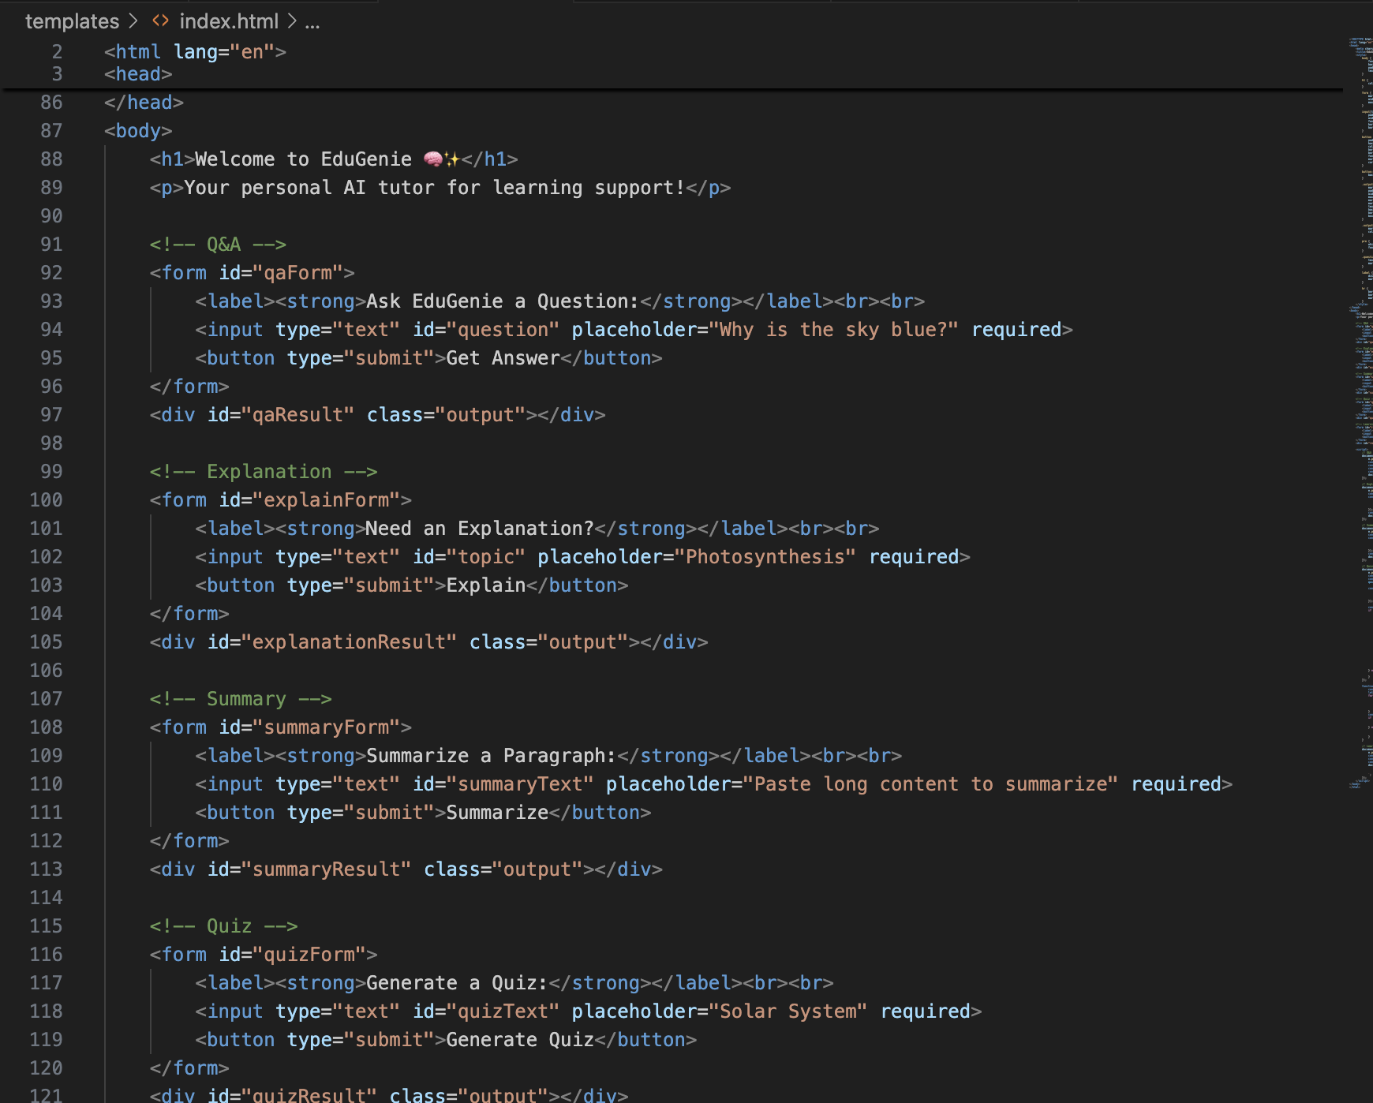
Fig. Showing Frontend Intergration
Activity 3.2: Live Integration
- Submitting the form sends a POST request to the FastAPI backend for processing.
- The generated result is displayed below the input area without requiring a separate page flow.

MILESTONE 4: Deployment
- Activity 4.1: Run Locally
Run locally with uvicorn main:app --reload
Navigate to: http://127.0.0.1:8000
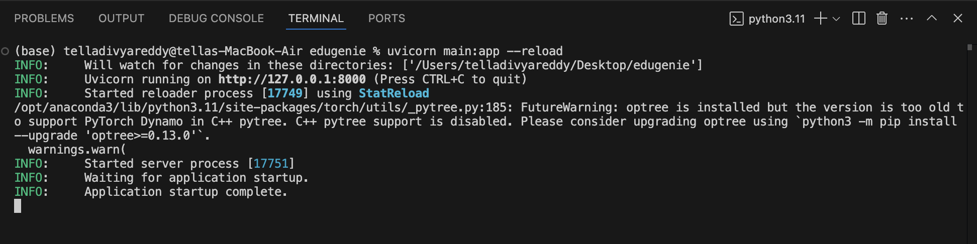
Fig. Showing the Application can be accessed
- Activity 4.2: Functional Testing
Ask a question
Get an explanation
Generate a quiz
Summarize content
Get a personalized learning plan

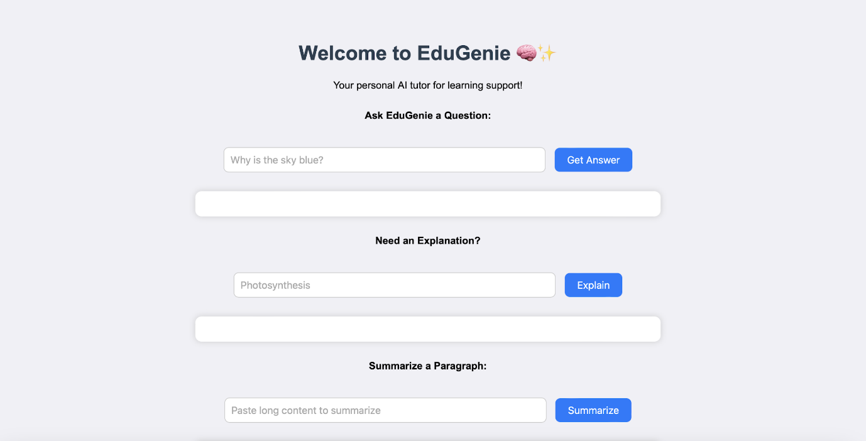
Fig. EDUGENIE

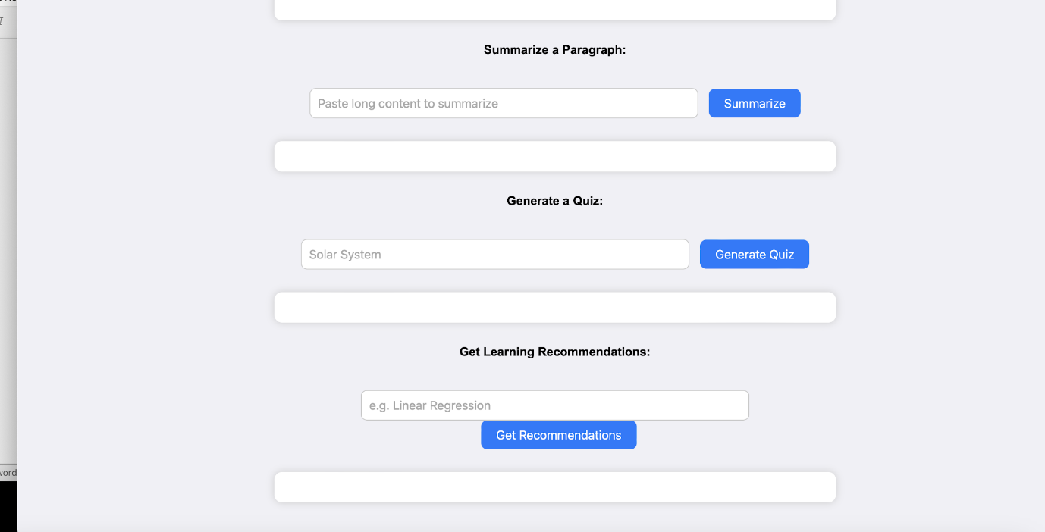
Fig. EDUGENIE

Exploring EduGenie:

  - Asking questions:

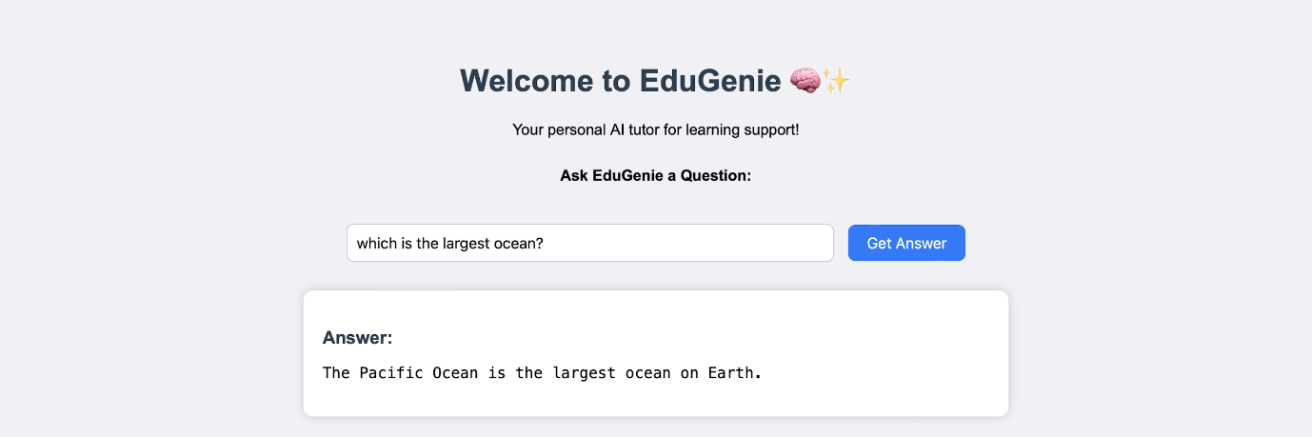

  - Explanation of any topic:

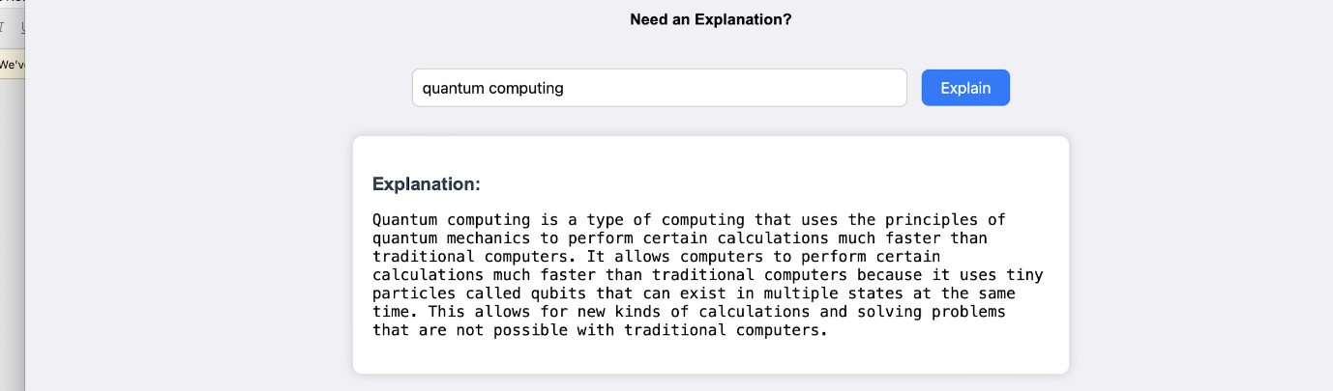
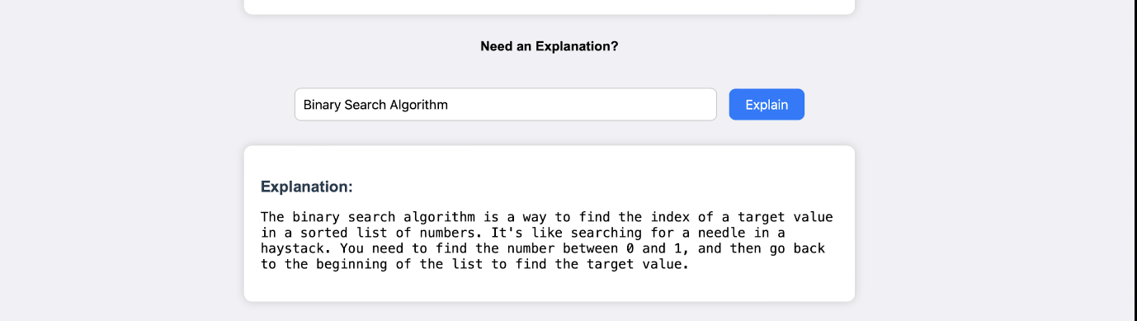
  - Summarising long paragraphs:
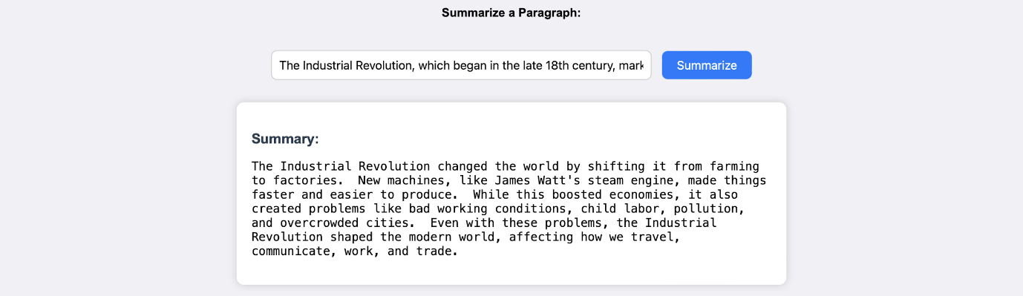

  - Generating quizzes:

It generates three questions with 4 options each. It corrects the answer if chosen wrong.
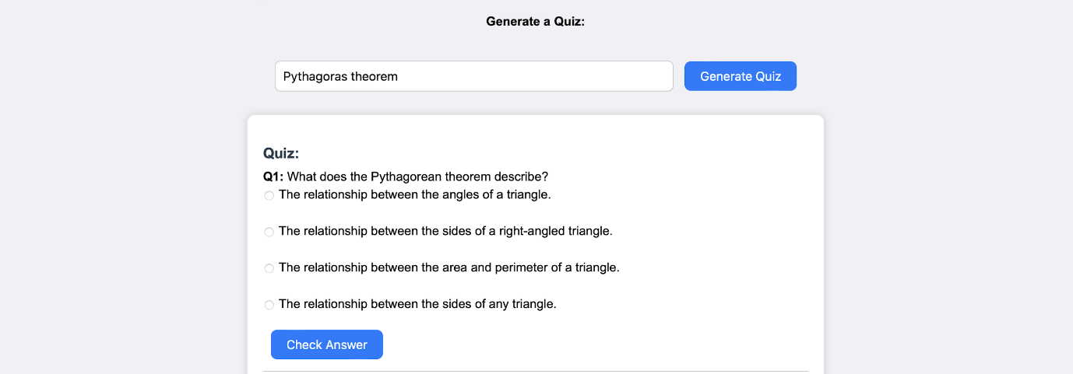
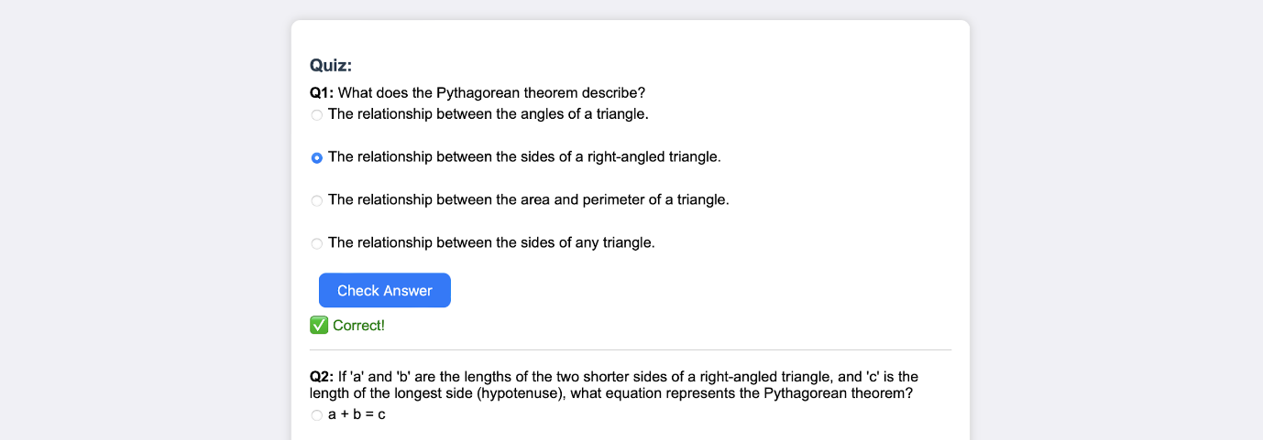
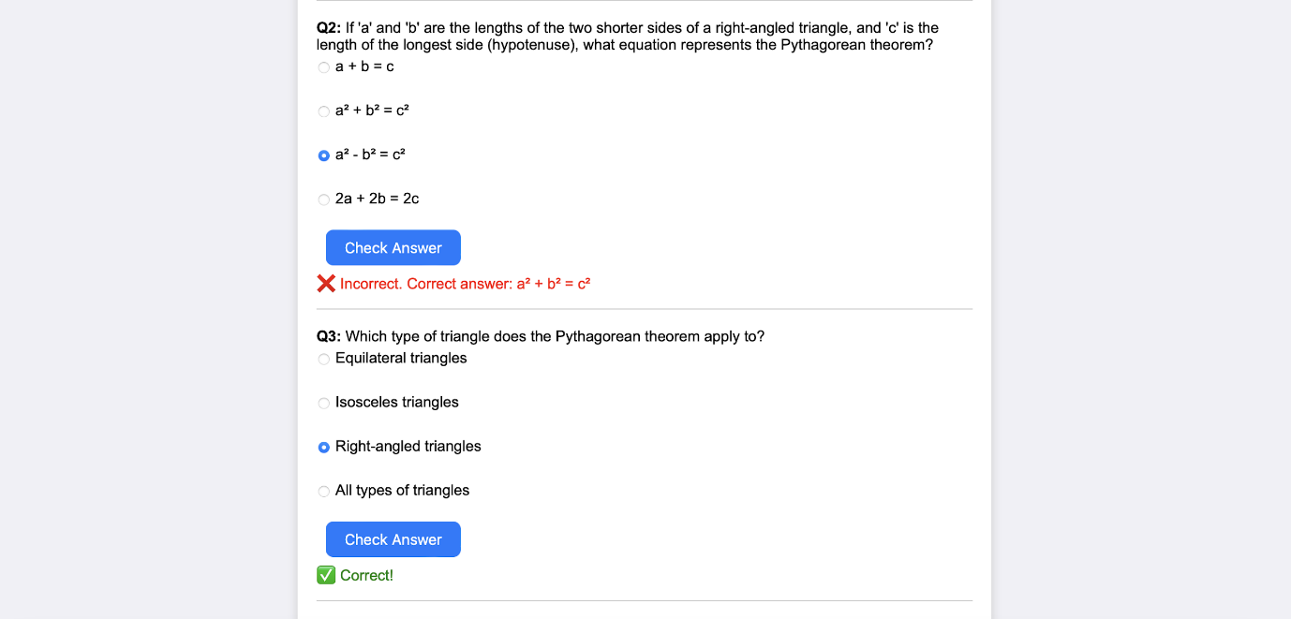

  - Guiding with learning recommendations from beginners level to advanced level
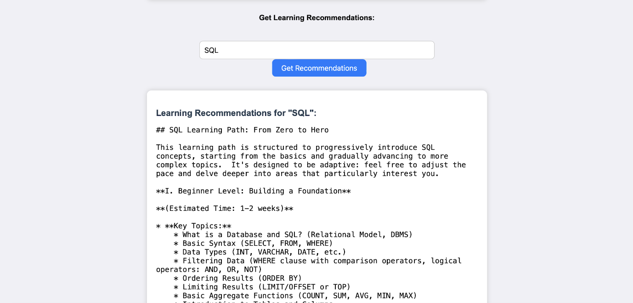
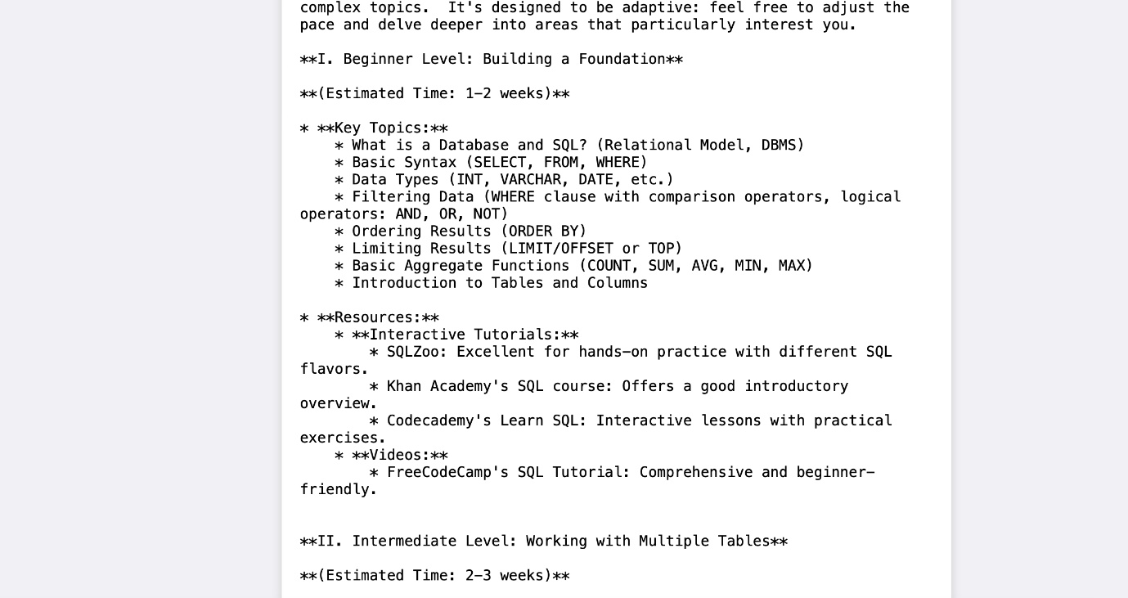
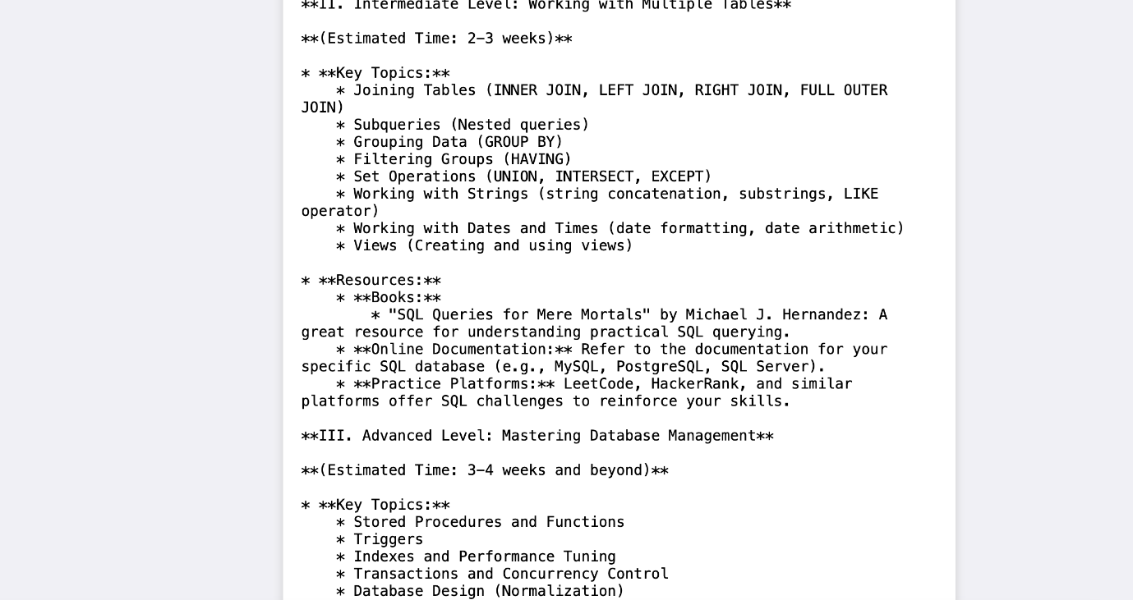
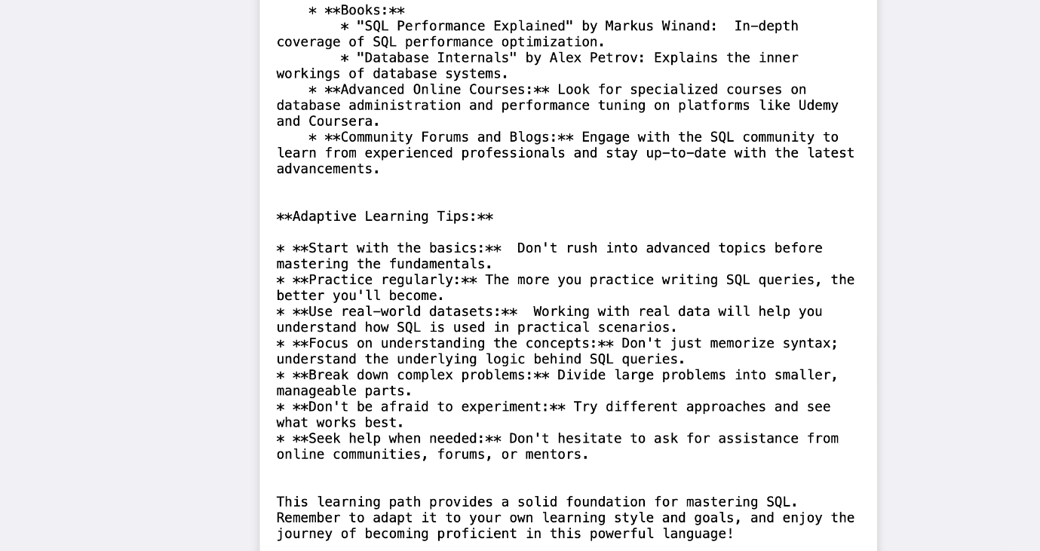
It provides along with details of resources from where to learn and stepwise guidance through-out.

Conclusion:
EduGenie is an accessible AI-powered educational assistant that combines cloud-based intelligence with a lightweight web interface. It supports self-learners, educational institutions, and content platforms by simplifying difficult concepts, answering questions, creating quizzes, summarizing material, and producing learning paths tailored to the requested topic. Its lightweight design also helps make these capabilities practical on systems with limited hardware resources.
The development of EduGenie brought together AI integration, interface design, and adaptable learning features. Generative AI changes the learning process from static content delivery into an interactive experience, while the modular structure makes individual features easier to maintain and extend. The cloud-connected backend also provides a foundation for future scaling and intelligent services.
The project also involved challenges such as maintaining the quality of AI-generated responses, supporting consistent performance across devices, and balancing personalization with general usability. These areas required repeated testing, prompt refinement, interface improvements, and attention to data privacy. The process provided practical experience in prompt engineering, cloud integration, user-centered design, and scalable application architecture.
Looking ahead, EduGenie holds immense potential for enhancement and expansion. One promising direction involves the integration of voice-based interaction, enabling users to learn hands-free using spoken commands and queries—a particularly useful feature for accessibility and multitasking. Multilingual support is another key frontier, helping bridge language barriers and reaching a broader global audience. A mobile application is also envisioned to make learning available anytime, anywhere, with offline features for uninterrupted access.
Furthermore, future iterations of EduGenie could incorporate progress tracking dashboards, allowing users to visualize their learning journey through metrics and insights. The addition of gamified elements such as badges, learning streaks, and challenge-based assessments can boost engagement and motivation. Adaptive learning paths powered by data analytics can guide users more intelligently through content based on their strengths and weaknesses.
From a collaboration perspective, EduGenie can evolve to support group study sessions, teacher or parent dashboards, and integration with Learning Management Systems (LMS) such as Moodle or Google Classroom. Input recognition for images and PDF files can expand how students interact with content, enabling snapshot-based doubt solving and resource summarization. Real-time sync and smart notifications will also improve continuity and interactivity.
EduGenie provides a foundation for personalized and accessible digital learning by combining question answering, explanations, quizzes, summaries, and learning recommendations in one assistant. Its modular design leaves room for additional capabilities while keeping the learner at the center of the experience. With continued development, it can grow into a broader learning companion that is practical, scalable, and adaptable.

